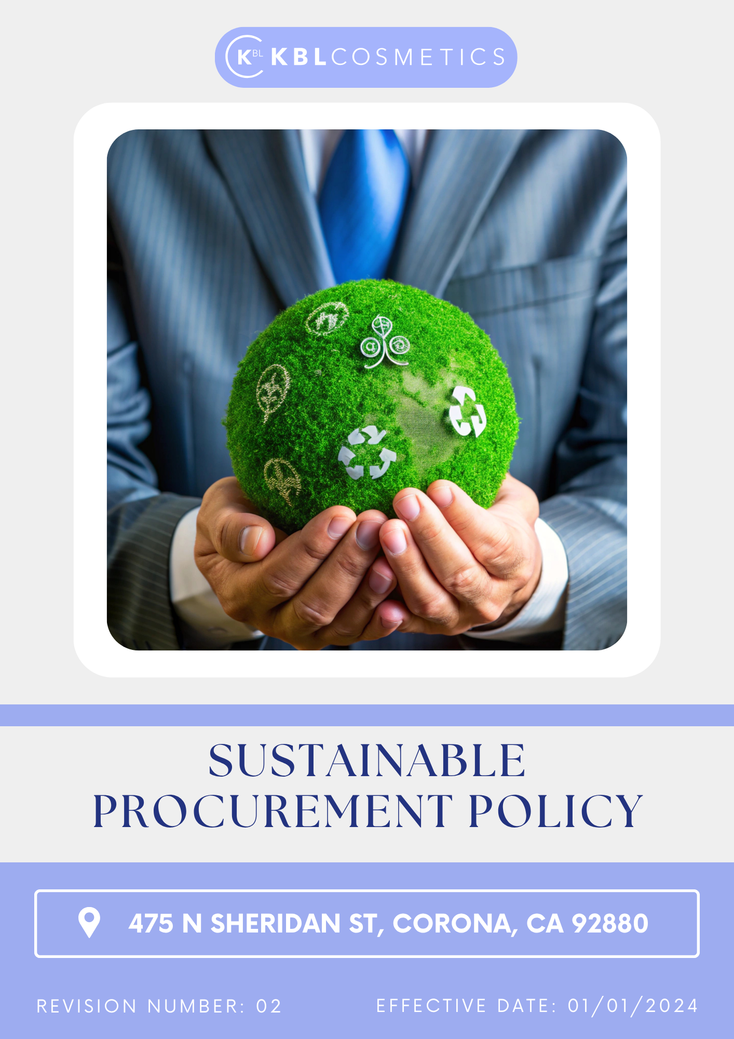

Table Of Contents

1. Introduction 3
2. The Arminak Solutions LLC dba KBL Cosmetics Approach 3
3. Scope 3
4. What's Expected 3
5. Journey to Sustainability: An Arminak Solutions LLC dba KBL Cosmetics Commitment: 4
6. General Sustainable Procurement Targets: 6
7. Responsibility: 6
8. Reporting Section: 8
9. Covered SDGs: 9
10. Review Mechanism: 9
11. Employee Acknowledgement Form: Sustainable Procurement Policy 10

Introduction
Leading innovator in the beauty and personal care sector, Arminak Solutions LLC dba KBL Cosmetics is dedicated to providing premium, ethically sourced, and eco-friendly products. Since sustainability and social responsibility are important to our organization, we make sure that every stage of our supply chain reflects these ideals. We make an effort to collaborate with vendors who share our dedication to moral corporate conduct, preservation of the environment, and equitable labor standards. This policy promotes a more sustainable and accountable supplier chain by providing a framework for our procurement operations.

The Arminak Solutions LLC dba KBL Cosmetics Approach
At Arminak Solutions LLC dba KBL Cosmetics, we integrate sustainability into our procurement practices by fostering strong partnerships with suppliers who share our commitment to ethical and environmental standards. We work closely with suppliers to ensure alignment with sustainability goals and provide support for continuous improvement. Additionally, we actively seek sustainable raw materials, packaging solutions, and manufacturing processes to reduce our environmental footprint. To ensure compliance with our sustainability criteria, we conduct comprehensive supplier evaluations, audits, and risk assessments. We prioritize supply chain transparency by requiring documentation and third-party certifications where applicable. Furthermore, we invest in training programs for employees and suppliers to promote sustainable best practices throughout our procurement processes.

We set annually goals, develop necessary capabilities, and commit appropriate resources to achieve this policy and aligning Arminak Solutions LLC dba KBL Cosmetics supply chain with this policy.

Scope
This policy applies to all procurement activities, including raw materials, packaging, and services, and covers all suppliers, contractors, and business partners.

   | ARMINAK SOLUTIONS LLC DBA KBL COSMETICS
 | Address: 475 N Sheridan St, Corona, CA 92880
 | https://kblcosmetics.com/

What's Expected

- Compliance with Laws and Regulations
All relevant national and international laws and regulations are closely adhered to by Arminak Solutions LLC dba KBL Cosmetics to foster sustainable procurement. Arminak Solutions LLC dba KBL Cosmetics has established key commitment to sustainable procurement practices:
- Climate Change: Reducing greenhouse gas emissions by sourcing from environmentally responsible suppliers.
- Water Conservation: Encouraging suppliers to implement water-saving measures and responsible wastewater management.
- Waste Management: Promoting a circular economy approach by reducing waste, increasing recyclability, and minimizing single-use plastics.
- Safe and Fair Working Conditions: Ensure that all suppliers adhere to workplace safety regulations and fair labor conditions.
- Diversity & Inclusion: Promote supplier diversity by working with minority-owned and women-led businesses.
- No Forced or Child Labor: Enforce zero tolerance for child and forced labor through rigorous audits and assessments.
- Employee Well-being: Support programs that enhance employee health, safety, and work-life balance across the supply chain.
- Long-term Partnerships: Foster relationships with suppliers that share our sustainability values and demonstrate continuous improvement.
- Capacity Building: Provide training and resources to suppliers on best sustainability practices.
- Ethical Sourcing Programs: Implement supplier incentives for ethical and sustainable business practices.
- Transparency & Reporting: Encourage suppliers to report on their sustainability efforts and participate in third-party sustainability assessments.
- Collaborative Innovation: Work with suppliers to develop new sustainable materials and production processes that align with our environmental goals.

Journey to Sustainability: An Arminak Solutions LLC dba KBL Cosmetics Commitment:
Establishes 2022 as the Baseline year for measuring progress and achievements in our sustainability initiatives.

- Environmental Issue:
  - Our objective is to significantly reduce Scope 3 emissions associated with procurement activities by an ambitious target of 20% by the year 2030, thereby contributing to a more sustainable and environmentally responsible supply chain.
  - We are committed to implementing effective strategies that will lead to a reduction in water usage throughout our supply chain, aiming for a substantial decrease of 25% by 2030, which will help conserve this vital resource.
  - We strive to ensure that a remarkable 30% of our packaging materials are either recyclable or biodegradable by the year 2030, reflecting our dedication to minimizing waste and promoting a circular economy.

  - We are focused on achieving complete traceability for key raw materials that are sensitive to biodiversity by 2030, ensuring that our sourcing practices are responsible and do not compromise ecological integrity.
  - Our plan includes the implementation of comprehensive measures designed to significantly reduce the carbon footprint of our supply chain, with a specific goal of demanding a 20% reduction in emissions related to our suppliers by 2030, thereby fostering a more sustainable partnership.

- Labor Practices and Human Rights:
  - Our objective is to conduct comprehensive supplier audits focusing on labor conditions, aiming for a complete 100% compliance rate by the year 2030.
  - We are committed to ensuring that at least 90% of our key suppliers adopt and implement fair wage policies by 2030. This commitment reflects our dedication to promoting equitable compensation practices that support the well-being of workers throughout our supply chain.
  - We have set an ambitious goal to increase our procurement from diverse suppliers by 25% by the year 2030.
  - We are dedicated to achieving 100% compliance in all supplier contracts by 2030. This commitment underscores our focus on accountability and transparency, ensuring that all contractual agreements are upheld to the highest standards.
  - Our plan includes the implementation of well-being programs that will reach 80% of our suppliers by 2030. These programs are designed to promote the health and welfare of workers, fostering a supportive environment that enhances productivity and job satisfaction across our supply chain.

- Supplier Engagement:
  - Our objective is to establish robust long-term sustainability commitments with a significant 70% of our key suppliers by the year 2030, ensuring that they align with our environmental goals and practices.
  - We are dedicated to providing comprehensive training on sustainability practices to at least 90% of our suppliers by 2030, equipping them with the necessary knowledge and tools to implement sustainable practices effectively.
  - We have plans to introduce innovative sustainability incentive programs that will encompass 40% of our suppliers by 2030, encouraging them to adopt environmentally friendly practices and contribute to our sustainability objectives.
  - We are committed to ensuring that a substantial 60% of our suppliers publish detailed sustainability performance reports by the year 2030, promoting transparency and accountability in their environmental impact.
  - We pledge to actively promote the adoption of low-carbon and eco-friendly transportation methods, with a goal of requiring 40% of our supplier shipments to utilize sustainable logistics solutions by 2030, thereby reducing our overall carbon footprint.

General Sustainable Procurement Targets:
- Carbon Reduction & Climate Impact
  - Reduce Scope 1,2&3 emissions from activities by 10% by 2030.
- Supplier Engagement & Compliance
  - Ensure that at least 100% of suppliers complete sustainability training programs by 2030.
  - Ensure that 100% of Suppliers are in Agreement with Supplier code of Conduct by 2030.
  - Ensure that 100% of suppliers undergo ESG on-site audits by 2030.
  - Ensure that 100% of suppliers undergo ESG Self-Assessment by 2030

Responsibility:

- Board of Directors:
The Board of Directors is responsible for setting the strategic direction for sustainable procurement at Arminak Solutions LLC dba KBL Cosmetics. They:
  - Oversee the implementation and effectiveness of the Sustainable Procurement Policy.
  - Ensure that sustainability risks in the supply chain are identified and mitigated at the highest level.
  - Promote a corporate culture that prioritizes responsible sourcing and ethical procurement.
  - Provide guidance and allocate resources to strengthen sustainable procurement initiatives.
- Chief Sustainability Officer:
The Chief Sustainability Officer plays a key role in ensuring that procurement activities align with sustainability goals. Their responsibilities include:
  - Developing and implementing sustainable procurement strategies in line with corporate sustainability objectives.
  - Monitoring supplier compliance with environmental, social, and ethical standards.
  - Reporting on procurement sustainability performance to the Board and stakeholders.
  - Leading initiatives to integrate sustainability into supplier engagement and corporate responsibility programs.

- Senior Management:
Senior Management is responsible for embedding sustainable procurement principles into daily business operations. They:
  - Lead by example in prioritizing sustainability within procurement decisions.
  - Ensure that procurement teams and employees understand and follow the Sustainable Procurement Policy.
  - Address procurement-related sustainability risks and take corrective actions when necessary.
  - Foster an open environment where suppliers and employees can raise sustainability concerns.

- Sustainability Committee:
The Sustainability Committee oversees procurement-related sustainability initiatives. Their key responsibilities include:
  - Reviewing and updating the Sustainable Procurement Policy as needed.
  - Evaluating the environmental and social impact of procurement practices.
  - Engaging with external stakeholders to promote sustainable sourcing.
  - Setting and monitoring sustainability-related procurement goals and targets.

- Procurement & Supply Chain Department:
The Procurement & Supply Chain Department ensures that ethical and sustainable sourcing practices are upheld. They:
  - Communicate sustainability expectations and requirements to suppliers.
  - Assess and monitor supplier compliance with sustainability standards.
  - Identify procurement-related sustainability risks and mitigate them proactively.
  - Encourage suppliers to improve their sustainability performance through training and collaboration.

- Compliance Manager:
The Compliance Manager ensures that Arminak Solutions LLC dba KBL Cosmetics adheres to legal and regulatory sustainability requirements in procurement. Their role includes:
  - Conducting audits and assessments of suppliers' sustainability practices.
  - Investigating and addressing non-compliance with the Sustainable Procurement Policy.
  - Providing training and guidance on regulatory and ethical sourcing requirements.
  - Keeping up to date with emerging sustainability laws and standards and ensuring compliance.

- Employees:
All employees involved in procurement and sourcing at Arminak Solutions LLC dba KBL Cosmetics are expected to support sustainable procurement efforts. They:
  - Adhere to the Sustainable Procurement Policy in their roles.
  - Report any sustainability or ethical concerns in procurement practices.
  - Make responsible purchasing decisions that align with the company’s sustainability commitments.
  - Contribute to a culture of sustainable procurement by collaborating with suppliers and stakeholders responsibly.

Reporting Section:
- Annual Public Sustainability Reporting:
  - External reporting is conducted annually to communicate our sustainable procurement performance to stakeholders, including employees, customers, investors, and regulatory bodies.
  - Reports are prepared in accordance with internationally recognized standards such as the United Nations Global Compact (UNGC), Global Reporting Initiative (GRI).

- Supplier Sustainability Compliance Reporting:
  - We require suppliers to submit annual reports detailing their compliance with environmental, social, and ethical procurement requirements, including any corrective actions taken.
  - Audits and third-party sustainability assessments are conducted to verify compliance with our Supplier Code of Conduct and Sustainable Procurement Policy.

- Stakeholder Engagement:
  - We actively engage with employees, suppliers, and other stakeholders to gather feedback, address concerns, and ensure transparency in our sustainable procurement practices.
  - Regular supplier assessments, training sessions, and stakeholder surveys help measure the effectiveness of our sustainable procurement initiatives and drive continuous improvement.

- Grievance Mechanisms:
  - A formal grievance mechanism is in place to allow employees, suppliers, and external stakeholders to report sustainability violations or unethical procurement practices confidentially and without fear of retaliation.
  - All reports are reviewed by the Compliance Manager and Procurement & Sustainability teams and addressed according to established procedures.

Covered SDGs:
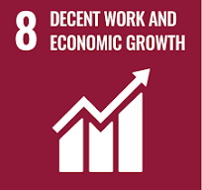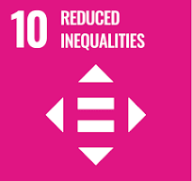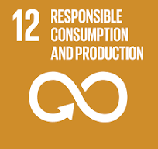

Review Mechanism:
- Annual Sustainable Procurement Performance Review
  - An annual review of sustainable procurement performance is conducted to assess progress toward responsible sourcing goals and compliance with the Sustainable Procurement Policy.
  - Key achievements, challenges, and areas for improvement are identified through a comprehensive evaluation process, including supplier assessments and sustainability audits.
- Continuous Improvement
  - Feedback from performance reviews, supplier audits, and stakeholder engagement is used to identify opportunities for continuous improvement in sustainable procurement practices.
  - Adjustments to procurement strategies, supplier requirements, and action plans are made as necessary to enhance sustainability performance and address emerging risks.

- Policy Review and Update
  - The Chief Sustainability Officer reviews this policy annually to ensure alignment with evolving regulations, industry best practices, and stakeholder expectations.
- Company can also change or review policy if any necessary changes is required.
  - Updates to the policy are communicated internally and externally, and relevant training is provided to procurement teams and suppliers to ensure awareness and compliance with sustainable procurement standards.

Version | Date | Description of Changes | Approved By
1.0 | 01-01-2024 | Initial release of the Sustainable Procurement Policy | Management
2.0 | 01-01-2026 | Add new content regarding Career Management and Training | Management

(Signature)
Approved By:
Designations:
Last Review Date: 01-01-2026 Next Review Date: 01-01-2031

Employee Acknowledgement Form: Sustainable Procurement Policy

I acknowledge that I have received, read, and understood Arminak Solutions LLC dba KBL Cosmetics Sustainable Procurement Policy. I am aware of the company's commitment to upholding sustainable practices, promoting a diverse and inclusive supply chain, and ensuring the protection of human rights across all operations and sourcing activities.
I understand my role in supporting this policy, including complying with all applicable laws and regulations, respecting human rights, and fostering a sustainable and inclusive work environment. I agree to adhere to sustainable practices in my daily work, report any sustainability concerns, and contribute ideas for continuous improvement.
By signing below, I confirm my commitment to upholding Arminak Solutions LLC dba KBL Cosmetics Sustainable Procurement Policy and supporting the company’s efforts in maintaining sustainable practices.

Employee Name: ______________________
Date: _______________
Employee Signature: ____________________

